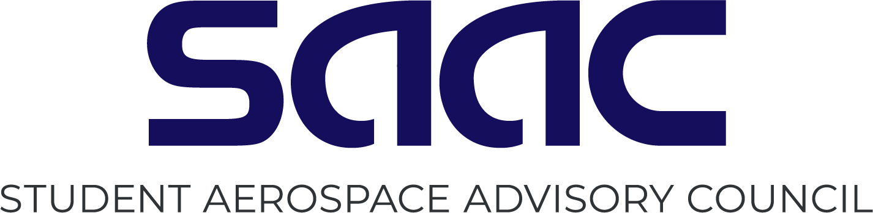

SAAC Application Form
Submit by April 19th, 2024 11:59PM

Name

Year at UND

Expected Graduation Date

Major

Phone

Email
Note: Please feel free to expand the boxes below.

Tell us why we should choose you to be on SAAC:

What is a current issue facing the aerospace college, and what steps would you as a SAAC member take to solve this issue:

*
*P

Note: Please attach your most recent résumé (Word Document or PDF) along with this application. Your application will be considered void without an attached résumé.

All claimed involvement on your résumé will be verified.

Please submit your application/résumé as attachments to SAACskyward@gmail.com

Note: Applicants must be available the evening of Monday (4/29) OR Tuesday (4/30) for an in-person interview on campus.

